**CHAPTER 6: IMPLEMENTATION**

The implementation phase involves deploying the PDS-Transport System into a real-world working environment. This phase ensures that all modules, components, and functionalities work as intended. The system is developed with a focus on efficiency, scalability, security, and ease of use, allowing transport and warehouse management to be streamlined effectively.

**6.1 Implementation Platform / Environment:**

The project is implemented using the MERN (MySQL, Express.js, React.js, Node.js) stack, ensuring scalability and flexibility in transport and warehouse management.

**Platform Details:**

* **Frontend:** React.js with Tailwind CSS for a modern and responsive UI.
* **Backend:** Express.js (Node.js) for API development and business logic.
* **Database:** MongoDB (NoSQL) for efficient data management.
* **Authentication & Security:** JWT-based authentication with Role-Based Access Control (RBAC).
* **Hosting / Deployment:**  
  ✅ **Frontend:** Hosted on Vercel for seamless deployment.  
  ✅ **Backend:** Hosted on Vercel for seamless deployment.  
  ✅ **Database:** Cloud-based SQL database.
* **Version Control & CI/CD:** GitHub is used for source code management and continuous integration (CI/CD) with automated deployments.

**6.2 Modules Specifications:**

The system is modular, meaning each functionality is built as an independent module while ensuring integration with other parts of the system.

Table 6.1 Technology Stack

|  |  |  |
| --- | --- | --- |
| **Modules** | **Technology Used** | **Key Features** |
| Authentication | JWT, bcrypt, MySQL | Secure login, user roles, session management |
| Dashboard | React.js, Tailwind CSS | Displays analytics and system overview |
| Employee Management | React.js, Express.js, MySQL | |  | | --- | |  |  |  | | --- | | CRUD operations for employee data | |
| Owner Management | React.js, Express.js, MySQL | Managing Warehouse Owners |
| Warehouse & Godown Management | React.js, Express.js, MySQL | Store Stock Details |
| Truck & Driver Management | React.js, Express.js | Assigning drivers to trucks, tracking dispatches |

**6.3 Outcomes:**

The PDS-Transport System significantly improves data management, warehouse tracking, and transport logistics. Below are some of the key findings and outcomes after implementation:

✅ **Faster Data Processing**: Real-time CRUD operations enhance efficiency.  
✅ **User-Friendly Interface**: The React.js + Tailwind UI makes navigation intuitive.  
✅ **Secure Authentication**: JWT and RBAC prevent unauthorized access.  
✅ **Scalable Database**: MySQL handles large amounts of warehouse and transport data effectively.  
✅ **Automated Reports**: DataTables generates real-time analytics, reducing manual reporting efforts.  
✅ **Seamless Communication Between Modules**: RESTful API integration ensures smooth data flow.  
✅ **Reduction in Manual Errors**: Automating truck dispatch and warehouse records minimizes human errors.

Fig 6.1 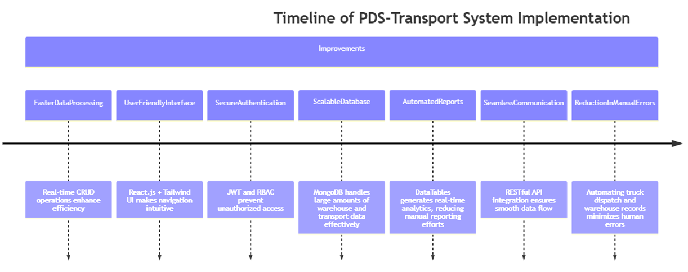Improvements Timeline

**6.4 Result Analysis:**

Table 6.1 Comparison: Traditional vs. New System

| **Feature** | **Traditional System** | **PDS-Transport System** |
| --- | --- | --- |
| Data Management | Manual record-keeping | Automated, real-time data storage |
| Truck Assignments | Paper-based tracking | Digital tracking with instant updates |
| Warehouse Stock | Prone to errors & mismanagement | Centralized & real-time stock updates |
| Employee Records | Maintained in Excel sheets | Fully integrated employee database |
| Reports & Analysis | Delayed & inaccurate | Instant, automated reports with DataTables |
| Security | Low (easily manipulated data) | High (JWT authentication & RBAC) |

**Deliberations & Future Enhancements:**

🔹 **Integration with GPS Tracking:** Adding live GPS tracking for trucks can further enhance transport monitoring.  
🔹 **Mobile App Support:** Developing a mobile-friendly app can improve accessibility for field workers.  
🔹 **AI-Based Demand Prediction:** Implementing AI for warehouse stock prediction can optimize inventory management.  
will improve communication.

Fig 6.2 Login Page

Fig 6.3 Dashboard

Fig 6.4 Owner Table

Fig 6.5 Owner Form

Fig 6.6 Employee Table

Fig 6.7 Employee Form

Fig 6.8 MSWC Godown TableA screenshot of a computer

AI-generated content may be incorrect.

Fig 6.9 MSWC Godown Form

Fig 6.10 Sub Godown Table

Fig 6.11 Sub Godown Form

Fig 6.12 Driver Table

Fig 6.13 Driver Form

Fig 6.14 Truck Table

Fig 6.15 Truck Form

Fig 6.16 Scheme Table

Fig 6.17 Scheme Form

Fig 6.18 First Transport Table

Fig 6.19 Transport Form